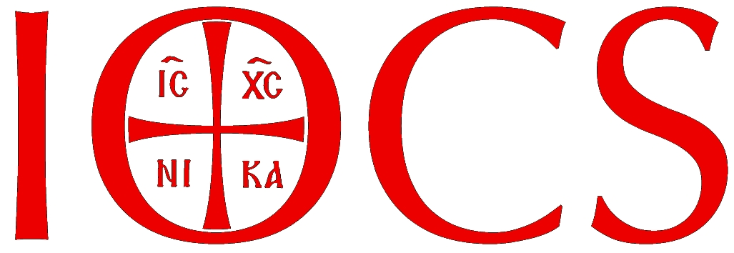
The Institute for Orthodox Christian Studies
Formally approved by the Pan-Orthodox Episcopal Assembly for Great Britain and Ireland

Application for Admission to the IOCS Distance Learning programme
Certificate in Orthodox Christian Studies

Title: / Name:
Address:
Date of Birth:
Occupation:
Telephone (Day): (Evening):
Email:
Church / parish affiliation:

Educational qualifications:
(Please give details of your previous education and / or relevant qualifications and attach any supporting documents.)

Qualification (name and type)  E.g.: BA(Hons) English Literature | Place of Study/Validating institution (including country if outside of the UK)  E.g.: University of London | Result  E.g.: 2:1

Date you wish to begin study:

English Language Proficiency (for overseas students only - English not first language: please provide name of the test, result, and date, and include a copy of the qualification with your registration):
Do you have a PC or a Mac ?
How did you hear about IOCS?
How are going to pay for your fees?
a) I wish to pay the discounted fee for the entire 2-year Certificate programme:
Yes No
b) I wish to pay the first module fee for now and then before each subsequent module:
Yes No
Methods of payment:
Online payment on IOCS website
(Please note that we prefer payments for distance learning to be made on the ‘Payments’ page on our website: http://www.iocs.cam.ac.uk/payments.html)

I wish to receive a proof of registration approval from IOCS, so that I can seek financial assistance from my Church/parish: Yes No

References: Please give the name and contact email address of one person from whom we can obtain a reference. A relative should not be given as a referee:

Referee name:

Referee email address:

How did you learn about the IOCS Distance Learning programme?

I have answered the above questions correctly and if accepted, I agree to comply with the academic and disciplinary regulations of the Institute for Orthodox Christian Studies.

Signed and dated
❖

Please return by email to:
info@iocs.cam.ac.uk
Alternatively, post the completed application to:
The Institute for Orthodox Christian Studies,
2 The Bounds, Cambridge Theological Federation, Westminster College
Lady Margaret Road, Cambridge CB3 0BJ, United Kingdom

