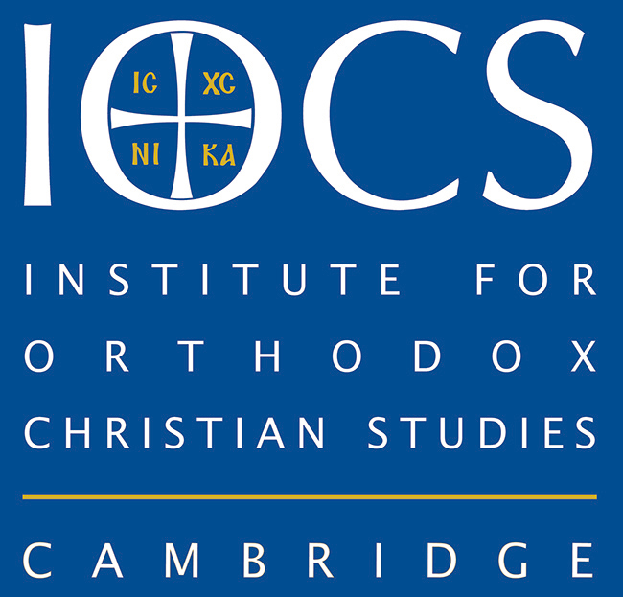
APPLICATION FOR A BURSARY FOR
THE MA IN CONTEMPORARY FAITH AND BELIEF
IN THE GLOBAL CONTEXT, 2022-2023

PERSONAL INFORMATION

Title
First Name(s)
Middle Name(s)
The name you prefer to use
Surname
Previous Surname (if different)
Date of Birth (dd/mm/yyyy)
Permanent Address |  | Present Address (if different from permanent)
Phone |  | Email

APPLICATION TO ANGLIA RUSKIN UNIVERSITY FOR THE MA COURSE
I have already applied online to the Anglia Ruskin University for the MA in Contemporary Faith and Belief in the Global Context, offered through IOCS/The Cambridge Theological Federation
https://aru.ac.uk/study/postgraduate/faith-and-belief#applynow_panel

QUALIFICATIONS COMPLETED
*Important: Please make sure that you have copies of ALL certificates, transcripts of results and any other related information and attach copies of these documents to this application. If your application is successful you may be required to provide originals.
Please give details of the highest academic and/or professional qualifications AND any qualifications in Theology.
Dates (mm/yy)  From – To | Place of Study/Validating Institution (including country if outside of the UK) | Qualification (name and type) |  |  | Results

Please make sure you also include the official certificates and academic transcripts for all your graduate and post-graduate degrees. Please note that we may require notarized translations into English for these documents.
STATEMENT
Please write a short statement of no more than 500 words saying how you think the MA in Contemporary Faith and Belief in the Global Context might enhance your study, research, work, life or ministry. Please also mention what ideas you have for future research if known.
Also, can you write a statement of no more than 500 words as a response to the question: What do you see as the contribution of (Orthodox) theology to the contemporary world?
Please attach a separate sheet with your statements to this application.

ENGLISH LANGUAGE EVIDENCE
If a non-native English speaker, please provide IELTS examination results or equivalent below.

Title/Component | Candidate Number | Grade | Date of testing(dd/mm/yy)

EMPLOYMENT
Are you currently employed?
YES |  | NO
If you have answered ‘Yes’ please supply details below.
Organisation name
Job title
Date appointed (dd/mm/yyyy)
Current responsibilities

Please supply previous employment details below.
Organisation | Position held | Start date | End date

REFEREES
Please ensure that at least one of your referees can speak to your academic ability. It is your responsibility to ensure your reference is provided: either include the reference(s) with this form or ask your referees to write directly to the IOCS. Both referees should know you in a professional capacity and would not normally be a close friend or family member.
Referee One Referee Two
Title |  |  |  | Title
Name |  |  |  | Name
Position |  |  |  | Position
Institution |  |  |  | Institution
Relationship to applicant |  |  |  | Relationship to applicant
If you are going through a church recommendation process, was this the reference you used? |  |  |  | If you are going through a church recommendation process, was this the reference you used?

DECLARATION
I declare that the information supplied on this form and in its supporting documentation is complete and accurate. I understand that if any of the information provided is discovered to be false, my application will be automatically rejected.
Signed: _________________________________________ Date: _________________________________
Please return this form and all supporting documents to the Institute for Orthodox Christian Studies, 31 Jesus Lane, Wesley House, Cambridge CB5 8BJ, United Kingdom.
Please also send a scan by email to info@iocs.cam.ac.uk.

